Cycle count test bug fix

1. SKU - 8441B001AA
2. Same Lot and LPN in 1 location
   1. Lot 0000000813
   2. Lot 0000000812
3. Loc
   1. A04L3
4. LPN(ID)
   1. CC5
5. QTY
   1. 100
   2. 100

Scenario

1. Request to count
2. 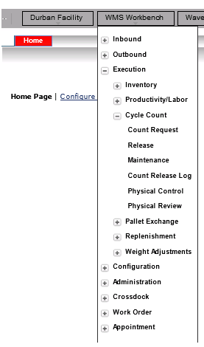
3. Enter the LOCATION and the ITEM to count
4. 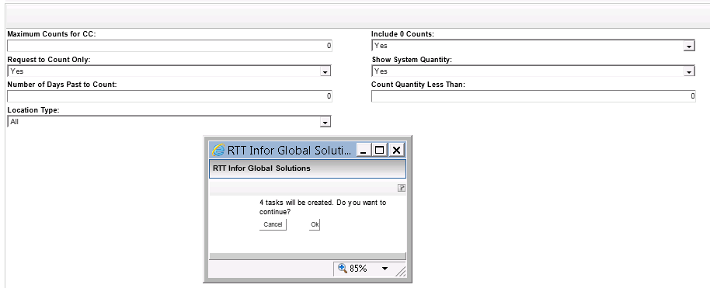
5. 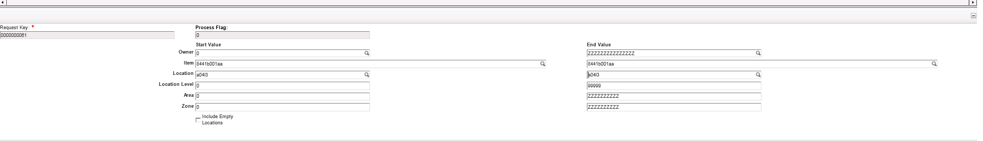
6. NOTE: the release did not create a task for the SKU and LOC.
7. 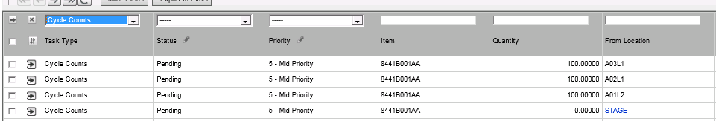
8. Please see screen shot below, it shows there are 2 different LOTS in one location with the same SKU
9. 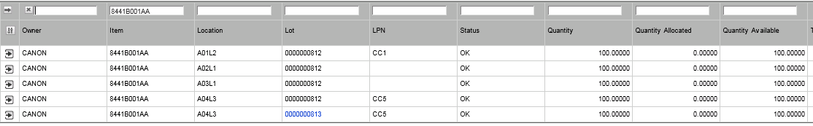
10. Count same ITEM and LOT in location
11. 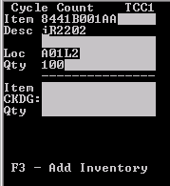
12. After counting all lots and LPN’s with incorrect QTY
13. 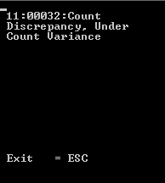
14. 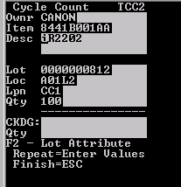
15. Count all LOCs and LPN’s for second location A02L1
16. 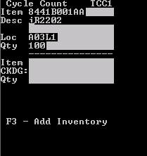
17. 3rd location to count
18. Error when entering the incorrect QTY
19. 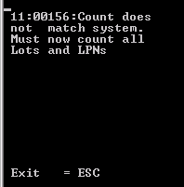
20. Count all lots and LPN’s
21. 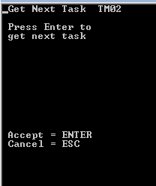
22. Counting all lots and LPN’s now
23. 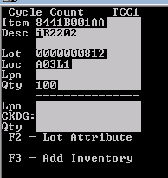
24. Task accepted and entering the QTY and the LPN is blank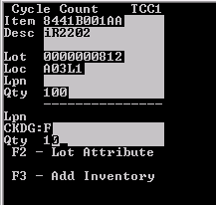
25. Incorrect QTY captured and the following is displayed
26. 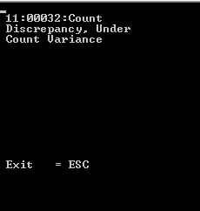
27. ESC out of the count, completed all lots and LPN’s
28. Next task to accept on the scanner
29. 